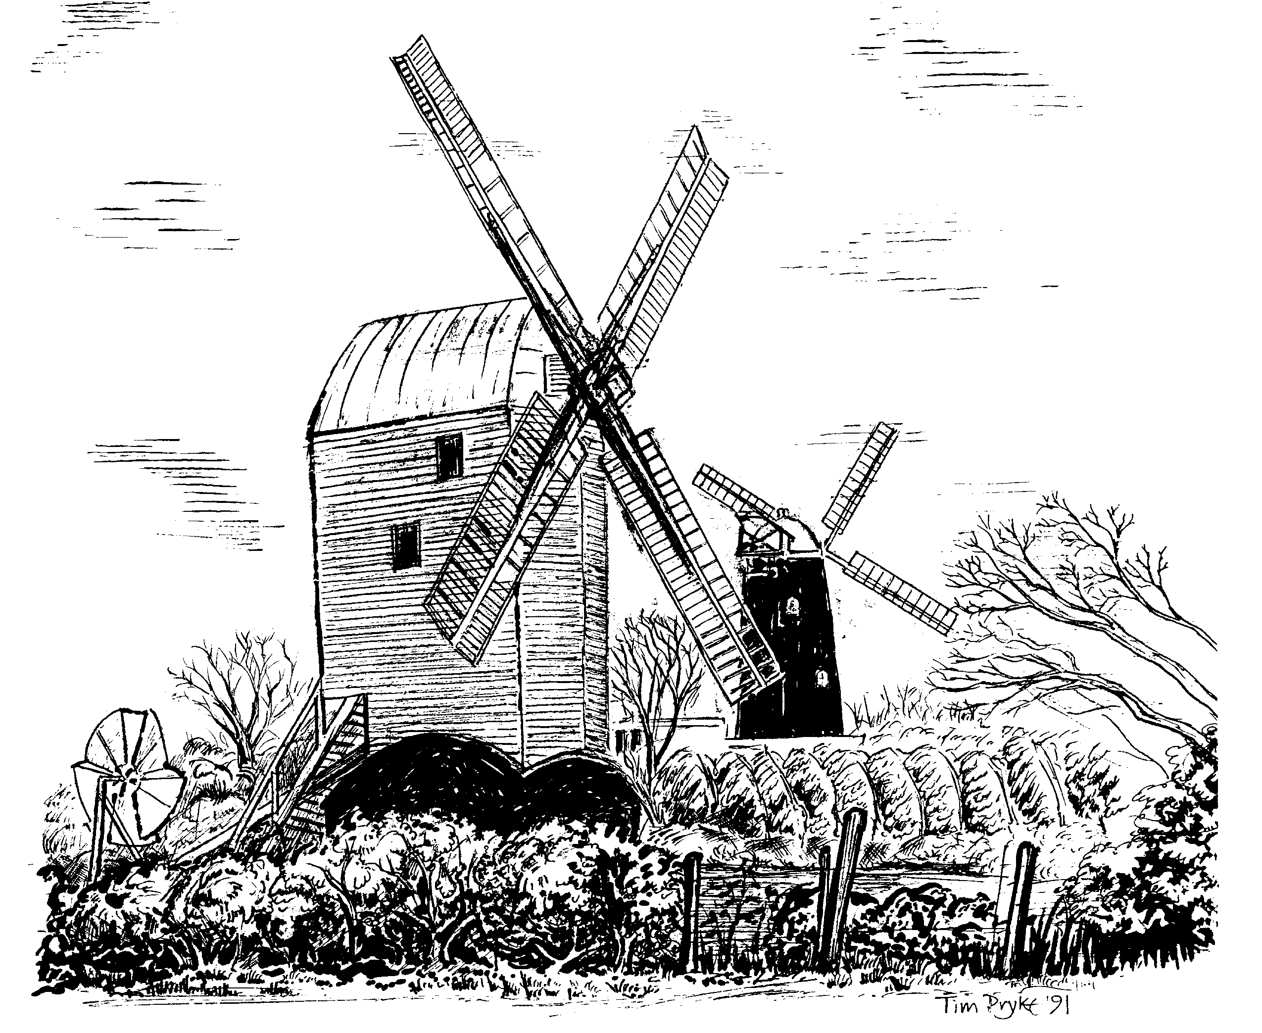

HASSOCKS PARISH COUNCIL

HASSOCKS NEIGHBOURHOOD PLAN

BUSINESS QUESTIONNAIRE

HASSOCKS NEIGHBOURHOOD PLAN

BUSINESS QUESTIONNAIRE

The Hassocks Parish Council is preparing a Neighbourhood Plan which will control the development of the parish for the next 20 years. A key part of this Plan is the development and support of local businesses.
Our vision for the economy of the village is “A strong sustainable Hassocks economy, where business profits fully from growth and where our residents have the opportunity to work within their community”.

This questionnaire seeks your views on the ways we can fulfill this vision by supporting your business and helping it to develop.

We would appreciate if you would complete the questionnaire online, or if you prefer, print off and submit
to the Parish Office by the 30th March

Individual data will be kept confidential

Thank you!

Neighbourhood Plan Working Group
(Economic Development and Tourism)

- Name and address of Business?

Building Name/No.
Street |  | Postcode

- What is the type of business?

[Please tick] Retail: Non Retail

- Please describe product and / or service provided

4 How many people are employed in the Business? [Please tick one box]

1 |  | 2-5
6-10 |  | 11-20
21 +

5 Where do the people employed in the Business live? (Please enter the
Number for each line)

In Hassocks Parish
Elsewhere in West Sussex
Outside West Sussex

6 What mode of transport do they use to come to work? (Please enter the
number for each line)

Walk/cycle
Bus
Train
Car

7 Please estimate the % of your purchases that come from Suppliers in:

[Please enter numbers totaling 100]

Area | Percentage %
Hassocks
West or East Sussex
Rest of UK
Internet

- Please estimate the % of your sales that come from Customers in:

[Please enter numbers totaling 100]

Area | Percentage %
Hassocks
West or East Sussex
Rest of UK
Internet

9 What can the community of Hassocks do to help your business grow?

10 What facilities do you wish were provided locally that would contribute to
business life in the village.

- Is your business connected to Tourism?

Yes No

- If so in what way?

- Has your business considered reducing your carbon footprint - for example by energy
efficiency, reducing waste or using renewable energy? Please specify

- And finally, is there anything not covered above that you think should be addressed by the Neighbourhood Plan?

……………..………………………………………………………………………………………………………..
……………..………………………………………………………………………………………………………..
……………..………………………………………………………………………………………………………..
……………..………………………………………………………………………………………………………..
……………..………………………………………………………………………………………………………..
……………..………………………………………………………………………………………………………..
……………..………………………………………………………………………………………………………..
……………..………………………………………………………………………………………………………..
……………..………………………………………………………………………………………………………..
……………..………………………………………………………………………………………………………..
……………..………………………………………………………………………………………………………..

Thank you for responding to this survey. All responses will be carefully considered and will help develop the Neighbourhood Plan

